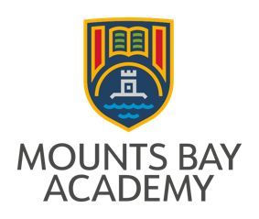
Equal Opportunities Monitoring Form

Equal Opportunities Monitoring Form
We are committed to having a workforce that promotes equality and celebrates diversity. To help us monitor and achieve this, we gather and use information about job applicants and our workforce to continually improve our employment policies and remove barriers to and within employment. The information you give is confidentially managed and does not affect your job application.
It will help us if you provide as much information as possible, but if you do not wish to answer any questions please leave them blank.
Job number:
Where did you see this job advertised?

What age group are you (years)?
Up to 20 |  | 20-25 |  | 26-30 |  | 31-35 |  | 36-40 |  |  | 41-45 |  | 46-50
51-55 |  | 56-60 |  | 61-65 |  | Over 65

What is your title?
Mr |  | Mrs |  | Miss |  |  | Ms
Other (please specify):

How do you describe your gender?
Male |  | Female

What is your marital status?
Single |  | Married |  | Divorced |  | Widowed |  | Civil Partnership

How do you describe your religion or belief (if any)?
Buddhism |  | Christianity |  |  |  | Hinduism |  |  |  |  | Islam
Judaism |  | Sikhism |  |  |  | Non belief |  |  |  |  | Withheld
Other (please specify):

Do you consider yourself to have a disability?
Yes |  | No
If your answer is ‘yes’, it would help us to know any barriers you have faced when dealing with us. Please also use this space to make suggestions on how we can improve.

How do you describe your ethnic origin?
Please read through carefully before selecting the ethnic group that you feel most closely reflects your background.

White
British |  | Cornish |  | Irish
Gypsy |  | Roma |  | Travellers of Irish Heritage
Other white background (please specify):

Mixed
White & Asian |  |  | White & Black African |  |  | White & Black Caribbean
Mixed Cornish
Other mixed background (please specify):

Black or Black British
African |  | Caribbean |  | Cornish
Other Cornish background (please specify):

Asian
Bangladeshi |  | Chinese |  | Indian |  |  |  |  | Pakistani
Cornish
Other Asian background (please specify):

Please return this form with your application to:

Email: mjenkin@mountsbayacademy.org

Post to: Malvina Jenkin
HR Manager
Mounts Bay Academy
Boscathnoe Lane
Heamoor
PENZANCE
TR18 3JT

